Citizen science app

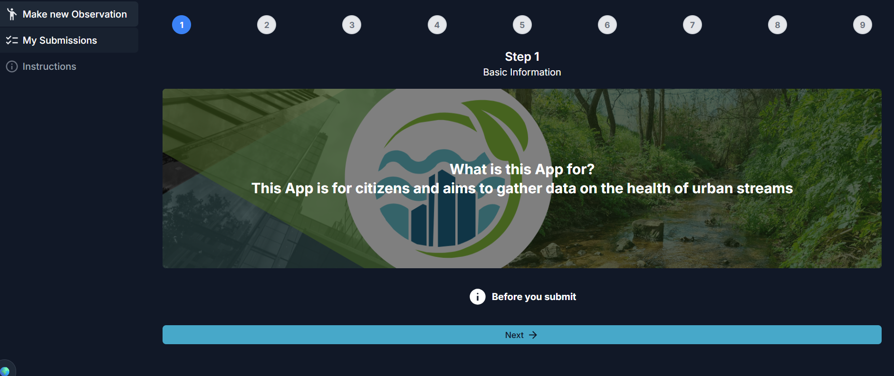

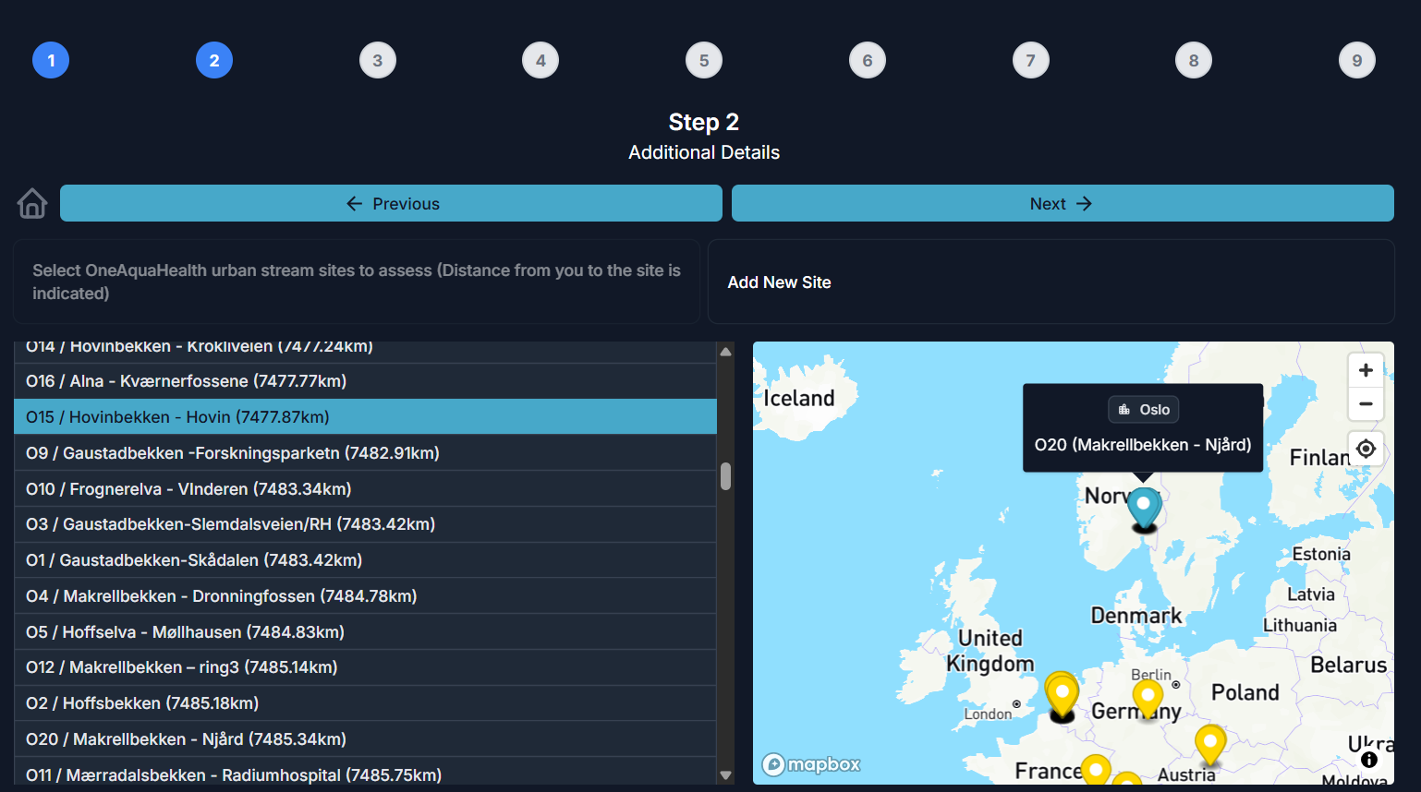

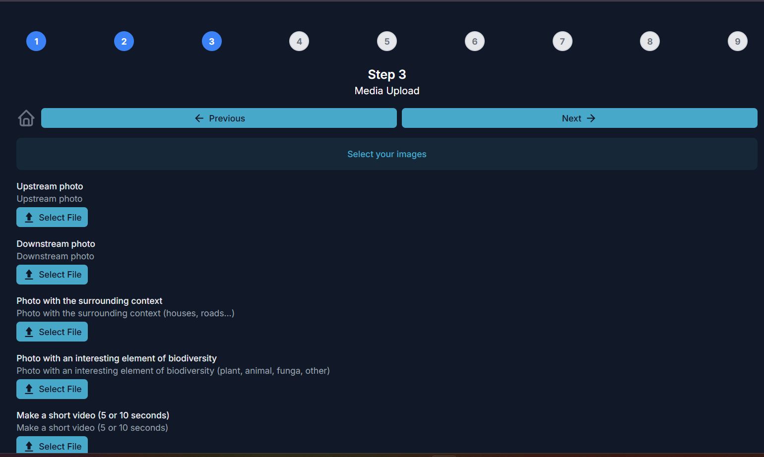
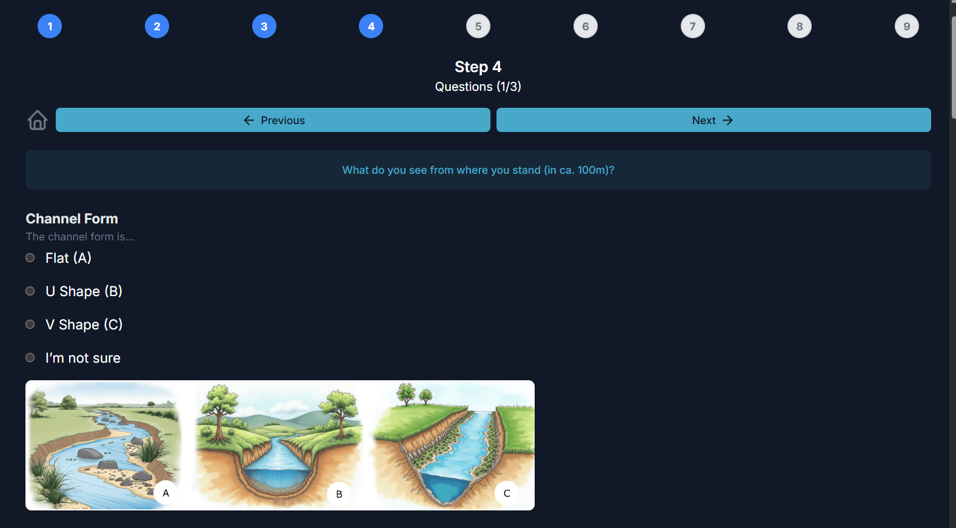
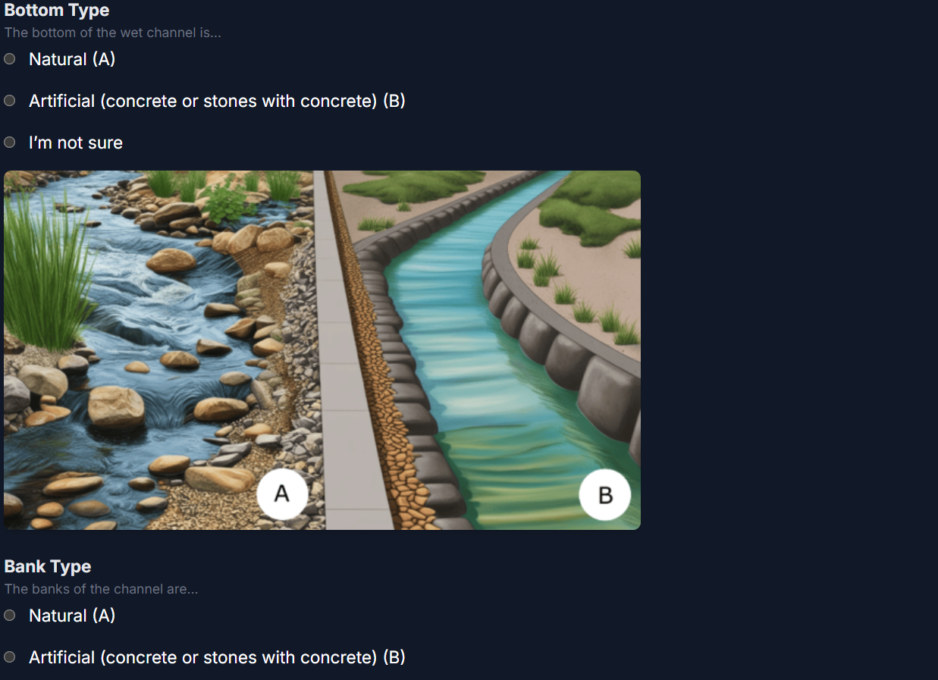
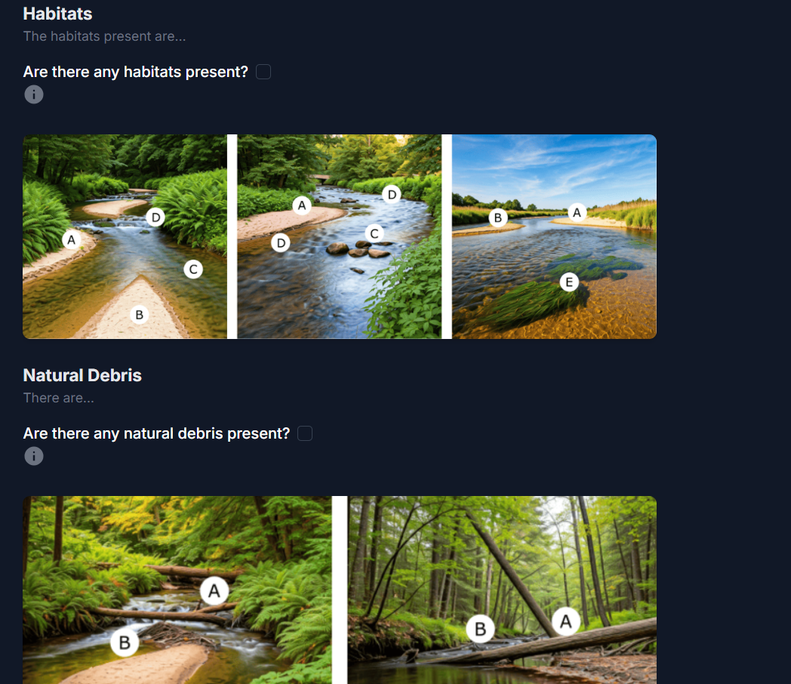
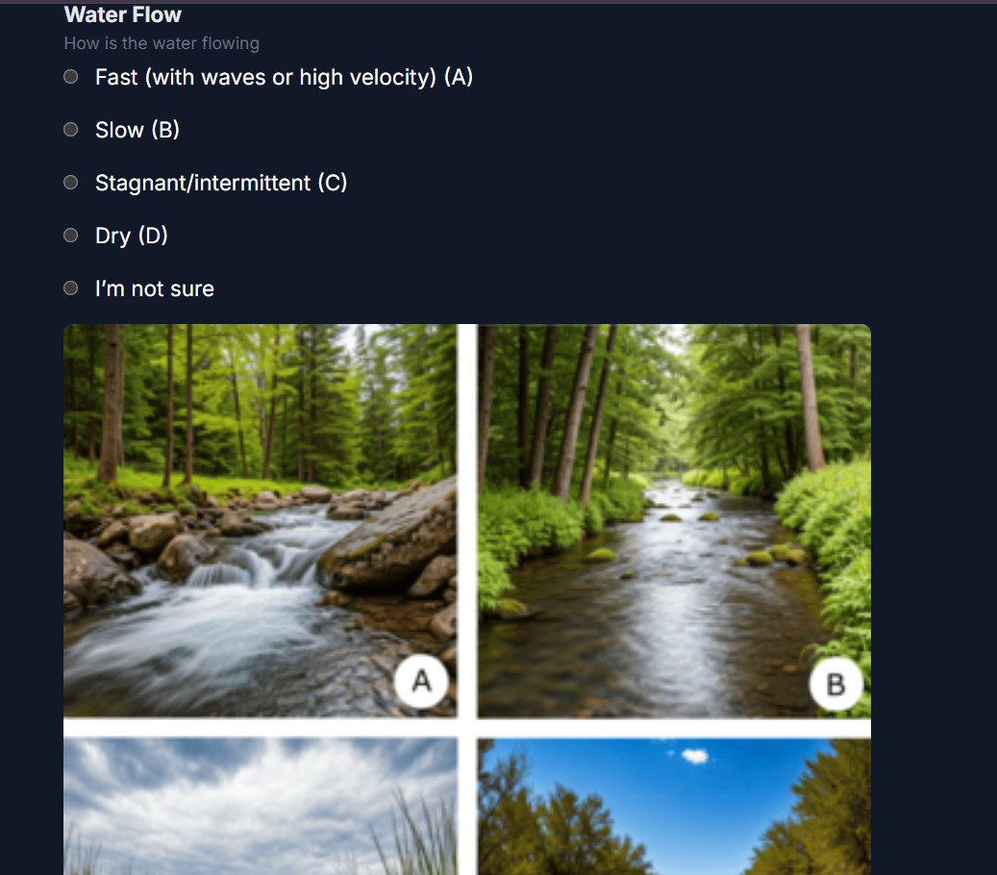

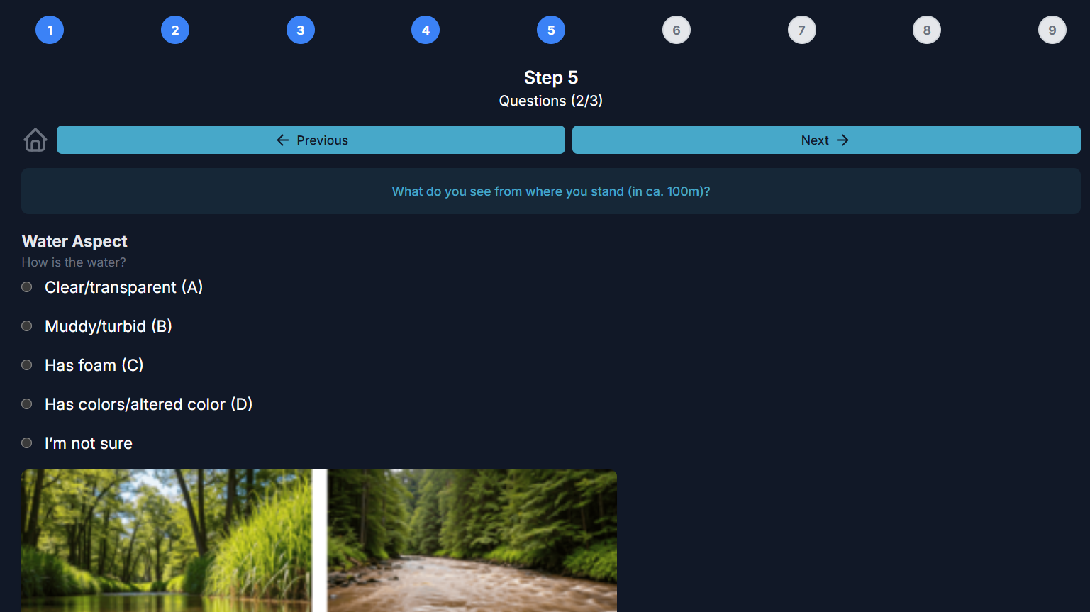

🌍
1
2
3
4
5
6
7
8
9

Step 5
Questions (2/3)
PreviousNext
What do you see from where you stand (in ca. 100m)?
Water Aspect
How is the water?
Clear/transparent (A)
Muddy/turbid (B)
Has foam (C)
Has colors/altered color (D)
I’m not sure
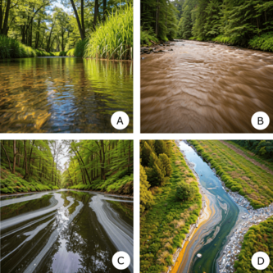
Water Withdrawal
Is there any kind of obvious water collection, use, removal from the stream?
Yes
No
I’m not sure
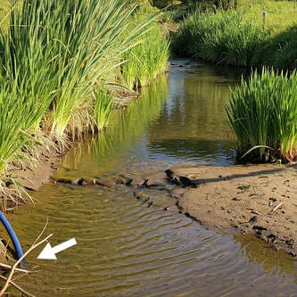
Barriers
Do you see any dams or other transversal artificial barriers (see some examples in images provided)?
Yes
No
I’m not sure
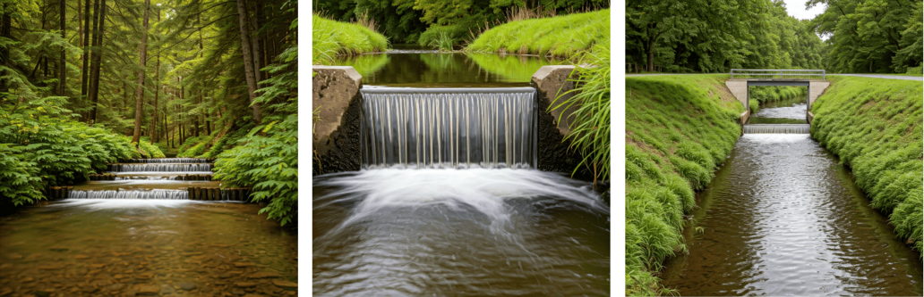
Draining Pipes
Are there pipes draining polluted water into the stream?
Yes
No
I’m not sure
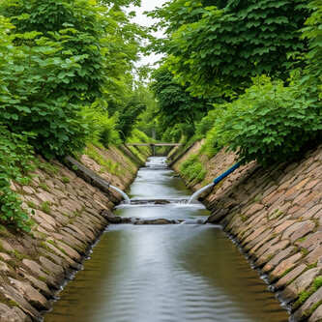
Sewage discharge
Is there any kind of water entry or discharge of sewage?
Yes
No
I’m not sure
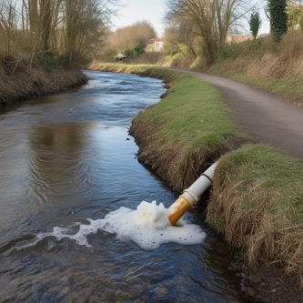
Construction
Is there any construction/works in stream?
Yes
No
I’m not sure
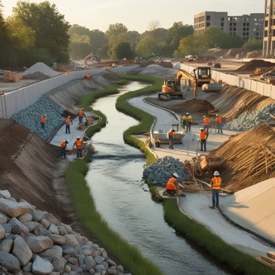
Water height
What is the water height?
Please give your estimate in meters (m), use a dot (.) as decimal point (e.g. 1.5m).
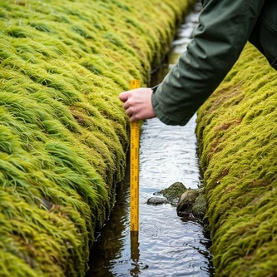
Previous

Yashas
- Current page:
- Make new Observation
- My Submissions
- Instructions
🌍
1
2
3
4
5
6
7
8
9

Step 6
Questions (3/3)
PreviousNext
In the margins/riparian zone (5-10m from the channel banktop)
Impervious Areas (Left)
Is more than one third of the left margin covered by impervious areas (such as roads, sidewalks or buildings)?
Yes
No
I’m not sure
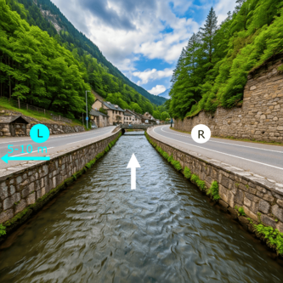
Impervious Areas (Right)
Is more than one third of the right margin covered by impervious areas (such as roads, sidewalks or buildings)?
Yes
No
I’m not sure
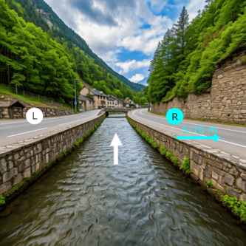
Vegetation (Left)
Is the left margin covered by vegetation?
Yes
No
I’m not sure
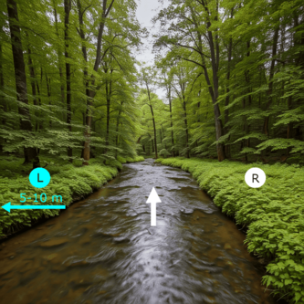
Vegetation Type (Left)
Which vegetation is dominant (meaning that it covers more than 50%, or half) in the left margin (first 5 meters from the channel banktop)?
Herbs (A)
Shrubs (B)
Trees (C)
I’m not sure
Don't forget to look to the left vegetation when in the downstream direction
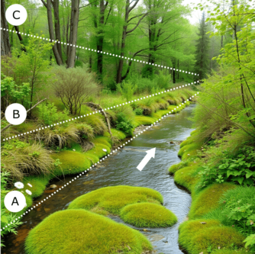
Vegetation (Right)
Is the right margin covered by vegetation?
Yes
No
I’m not sure
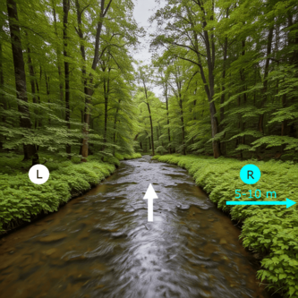
Vegetation Type (Right)
Which vegetation is dominant (meaning that it covers more than 50%, or half) in the right margin (first 5 meters from the channel bank/top)?
Herbs (A)
Shrubs (B)
Trees (C)
I’m not sure
Don't forget to look to the right vegetation when in the downstream direction
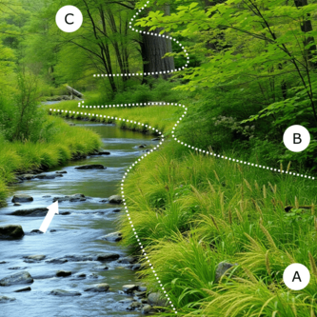
Invasive Species
Do you see any non-native or invasive plant species?

Which ones?
Vegetation Cuts
Have there been recent cuts if vegetation (partial or total) on the banks (or just one of the banks) of the stream?
Yes
No
I’m not sure
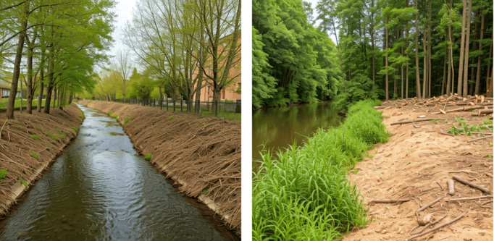
PreviousNext

